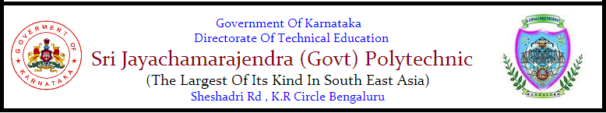

**PROGRAMME: DIPLOMA IN COMPUTER SCIENCE ENGINEERING.**

**COURSE: PROJECT WORK-1**

**PROJECT SYNOPSIS ON**

**IOT BASED SMART AGRICULTURE AND LIVESTOCK FEEDING MECHANISM (SMALiv-e)**

**SUBMITTED BY:**

**(5TH SEM STUDENTS)**

**DEEPA RANI.B. (102CS15007)**

**MAHALAKSHMI.M. (102CS15023)**

**SUSHMITHA.A.T. (102CS15056)**

**YOGESHWARI.J. (102CS163)**

**UNDER THE GUIDANCE OF:**

**HARITHA.S.M.**

**LECTURER OF COMPUTER SCIENCE & ENGG. DEPARTMENT,**

**S.J. (GOVT).POLYTECHNIC , K.RCIRCLE , BANGALORE.**

**SMALiv-e**

***IOT BASED SMART AGRICULTURE AND LIVESTOCK FEEDING MECHANISM***

1. **INTRODUCTION**

* **Agriculture** plays a crucial role in the life of an economy. It is the backbone of our economic system.
* **Feeding** is the most important factor in successful farming. An animal will only perform at its potential if it is fed well.
* In the real world, many farmers face problem in monitoring their farms. The farmers have more difficulties to monitor all the farms at the same time. Hence the project is developed to monitor the farms in the field using the concept of IoT( Internet of things )..
* **The Internet of Things (IOT)** is inter-networking of physical devices. This system has ability to transfer data over a network without requiring human-to-human or human-to-computer interaction.
* This project uses **Soil moisture sensors** which are placed on the fields to detect the water quantity present in land or sand and **IR sensor** is used to identify the animals and human entry in the field .**Temperature sensor** sense the heat in the atmosphere, according to the climate, the switch will be automatically ON/OFF motor.
* The project uses **Arduino** micro controller which is controller to process the information and send the processed information to Android phone using **GSM** module.

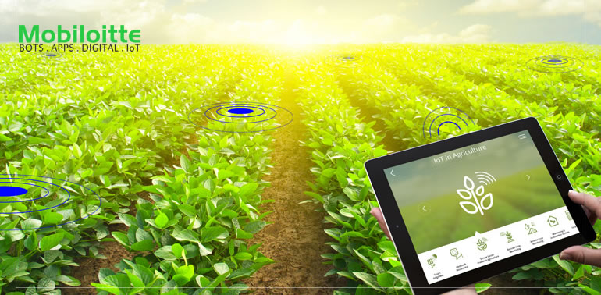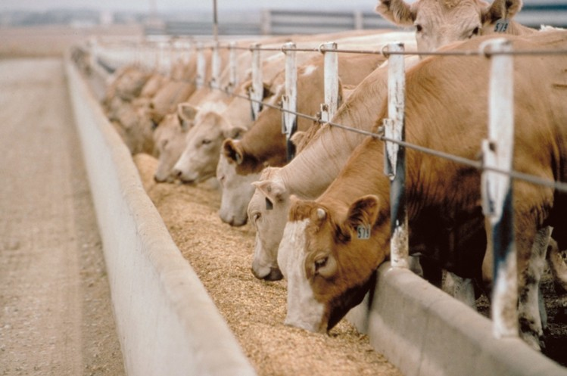

**2. OBJECTIVE OF THE PROJECT**

* To minimize the manual intervention by the farmer in irrigation activity and feeding the livestock.
* Manual means of feeding livestock can be replaced with automatic means of livestock feeding, thus ensuring less wastage of animal feed.
* To save the water from being wasted by unplanned usage of water.
* To make agricultural field smarter by using Android phones.
* To improve management of irrigation system.
* To save time ensuring farmers can focus on other activities.
* To reduce wastage of crops made by pests using motion detection and also improve security of crops.
* To help the farmer to know his field status in his home or he may be residing in any part of the world.
* To modernizing agriculture technology by programming components and built the necessary component for the system.

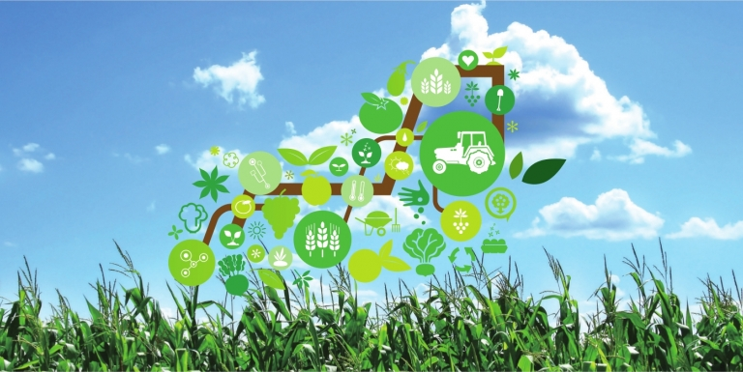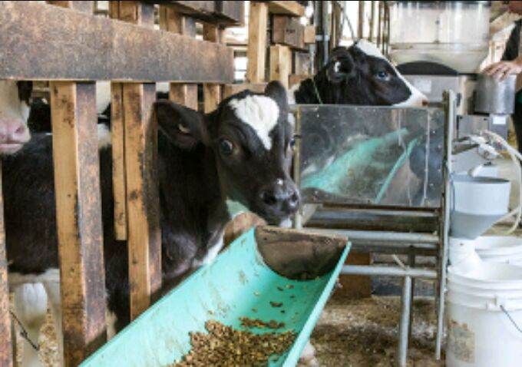

**3. PROBLEM STATEMENT**

* In the present era one of the greatest problems faced by the world is water scarcity and agriculture being a demanding occupation consumes plenty of water. Therefore a system is required that uses water judiciously.
* To feed more than necessary would be wasteful and uneconomical and could lead to health problems in the livestock. Also, dispensing the feed to livestock is also a pain area which can be addressed.
* Irrigation of plants is usually a very time- consuming activity, to be done in a reasonable amount of time, it requires a large amount of human resources. Traditionally all the steps were executed by humans. Nowadays some systems use technology to reduce the number or workers or the time required to water the plants.
* During manual irrigation, the water requirement of plants/crops is not monitored. Even when the soil is moist enough, water is still provided. This water is not absorbed by the plants and thus is wasted. Hence a system is to monitor the water requirements of the plant is needed.
* In addition to the excess cost of waterman labour is becoming more and more expensive. Technology is probably a solution to reduce costs and prevent loss of resource, this project can be a strong way to tackle such a situation.
* This problem can be perfectly rectified if we use smart agriculture technology in which the irrigation will take place only when there will be intense requirement of water, as suggested by the moisture in the soil.

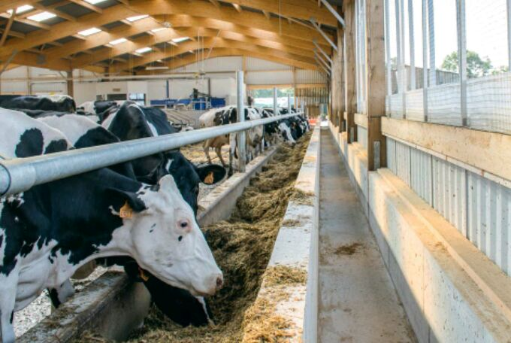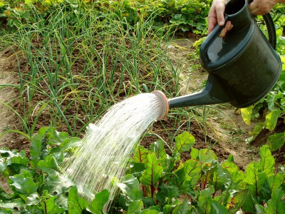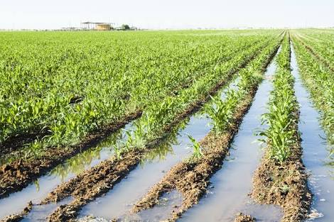

**4. ADOPTED METHODOLOGY**

* **Methodology** is the systematic, theoretical analysis of the methods applied to a field of study.

* A methodology is a model, which project managers employ for the design, planning, implementation and achievement of their project objectives.
* There are different project management methodologies to benefit different projects like.
* **Algorithms**
* **Data Flow Diagrams**
* **Block Diagrams**
* **etc**
* In our project the adopted methodology is **Block Diagram** which shows how we implement the IOT based Smart agriculture and livestock feeding mechanism.
* The automated irrigation system will cover a plot of land with sensors in it which will provide real-time data for the farmer.

Cultivable land

Real time data view

Livestock feeding

**4.1. BLOCK DIAGRAM**

* A **block diagram** is a diagram of a system in which the principal parts or functions are represented by blocks connected by lines that show the relationships of the blocks.
* They are heavily used in engineering in hardware design, electronic design, software design, and process flow diagrams.
* Block diagrams are typically used for higher level, less detailed descriptions that are intended to clarify overall concepts without concern for the details of implementation.

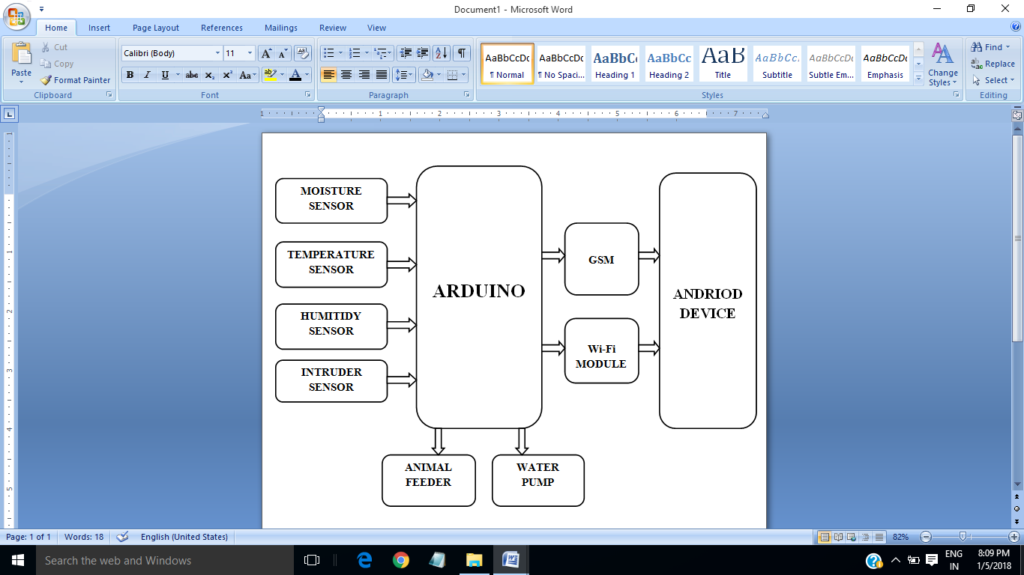

**5. HARDWARE REQUIREMENT**

* **ARDUINO UNO**

The Arduino Uno is a microcontroller board based on the ATmega328 (datasheet). It has 14 digital input/output pins (of which 6 can be used as PWM outputs), 6 analog inputs, a 16 MHz ceramic resonator, a USB connection, a power jack, an ICSP header, and a reset button. It contains everything needed to support the microcontroller, simply connect it to a computer with a USB cable or power it with a AC-to-DC adapter or battery to get started. The ATmega328 has 32 KB (with 0.5 KB used for the boot loader). It also has 2 KB of SRAM and 1 KB of EEPROM (which can be read and written with the EEPROM library). The Arduino Uno can be programmed with the Arduino software. The Arduino Uno can be programmed with the ***Arduino IDE.***

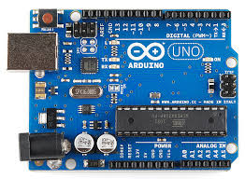

* **SOIL MOISTURE SENSOR**

Soil moisture sensors measure the volumetric water content in soil..Soil moisture sensor uses the capacitance to measure the water content of soil. It is easy to use this sensor. Simply insert this rugged sensor into the soil to be tested, and the volumetric water content of the soil is reported in percent. Soil moisture sensors measure the volumetric water content in soil.

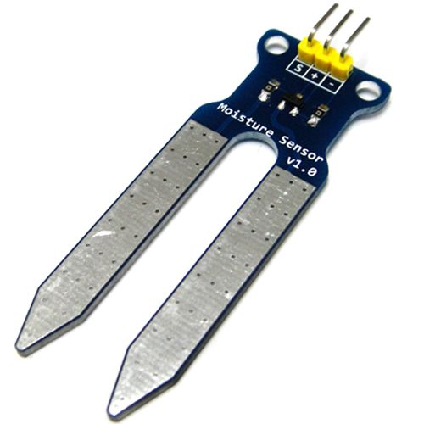

* **TEMPERATURE SENSOR**

A temperature sensor is a device, typically, a thermocouple or RTD that provides for temperature measurement through an electrical signal. A thermocouple (T/C) is made from two dissimilar metals that generate electrical voltage in direct proportion to changes in temperature.

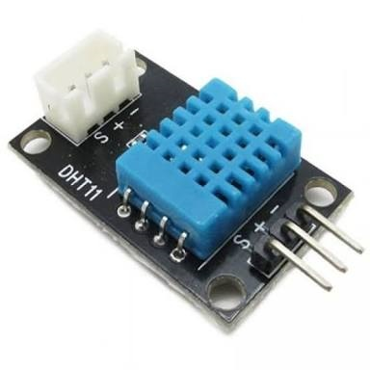

* **HUMITIDY SENSOR**

A **humidity sensor** senses, measures and regularly reports the relative humidity in the air. It measures both moisture and air temperature and express relative humidity as a percentage of the ratio of moisture in the air to the maximum amount that can be held in the air at the current temperature.

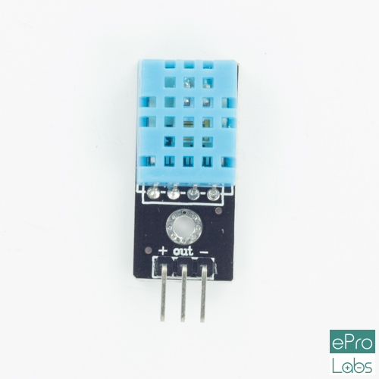

* **IR SENSOR**

An IR sensor senses certain characteristic of its surroundings by either emitting and/or detecting infrared radiation. Infrared sensors are also capable of measuring the heat being emitted by an object and detecting motion.

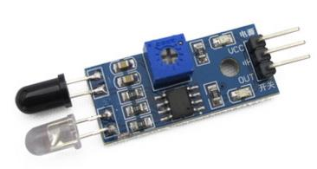

* **WATER PUMP**

A pump is for raising or circulating Water Pump is a mechanical device that moves fluid or gas by pressure or suction.

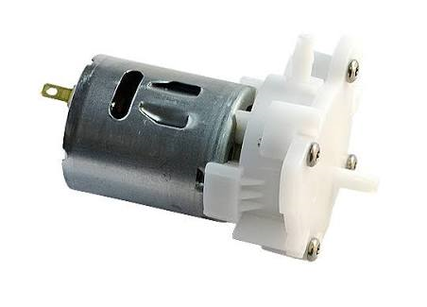

* **Wi-Fi MODULE**

A Wi-Fi module is a component that provides wireless connectivity with the system; or in some cases, the. Bluetooth may be an accessory or peripheral.

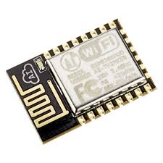

* **GSM MODULE**

A GSM module or a GPRS module is a chip or circuit that will be used to establish communication between a mobile device or a computing machine and a GSM or GPRS system. The modem (modulator-demodulator) is a critical part here. It requires a SIM (Subscriber Identity Module) card just like mobile phones to activate communication with the network. Also they have IMEI (International Mobile Equipment Identity) number similar to mobile phones for their identification.

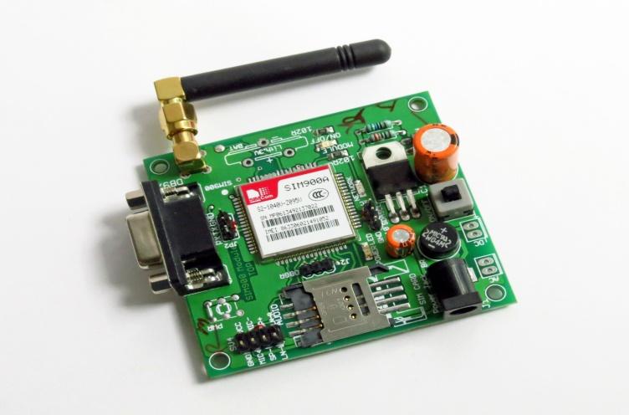

* **POWER SUPPLY**

It is used to run the system. Can use a power supply circuit with transformer and regulator, or simply a 12V battery.

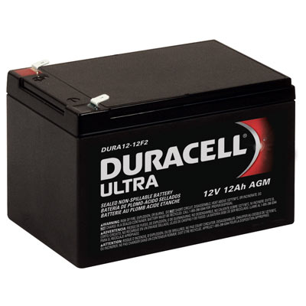

* **MOTOR STEEL L293N**

Arduino can drive many kinds of motors. A Motor Driver will usually be a circuit board with several electronics components on it, including a high-power motor driver chip or some power transistors. This includes a heat sink for the L293N chip, allowing higher currents. It is also less expensive than a shield version. Often it can be mounted near the motors

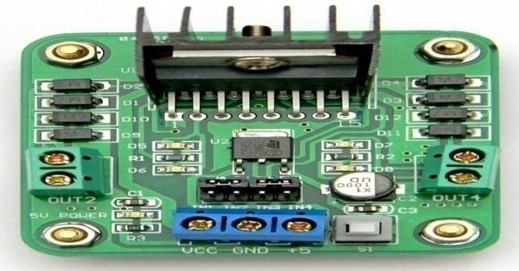

* **RELAY**

A relay is an electronic component used for controlling mechanical switching operations through an electronic signal. It can be used for controlling high voltage devices with a small amount of voltage. Both AC and DC components can be controlled by a relay.

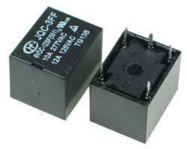

* **ANDROID DEVICE**

Android device means a mobile with android operating system.

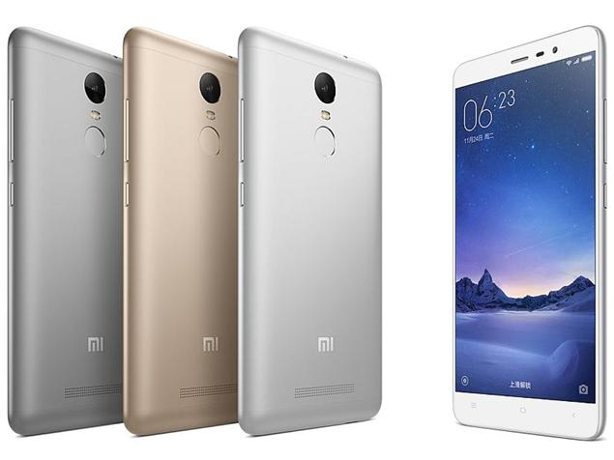

**6. SOFTWARE REQUIREMENT**

* **Arduino Software**

**Arduino Software** (**IDE**) makes it easy to write code and upload it to the board.It runs on Windows, Mac OS X, and Linux. The environment is written in Java and based on Processing and other open-source software. This software can be used with any Arduino board.



* **Firebase Database**

**Firebase** is a mobile and web application development platform developed by Firebase, Inc. in 2011, then acquired by Google in 2014. Firebase provides a real time database and backend as a service. The service provides application developers an API that allows application data to be synchronized across clients and stored on Firebase's cloud. The database is also accessible through a REST API and bindings for several JavaScript frameworks such as AngularJS, React, Ember.js and Backbone.js.

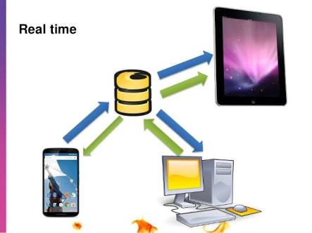

**LANGUAGE USED**

* Embedded C **:** Embedded C is a language used for programming the microcontroller.

**7. ADVANTAGES**

1) Relatively simple to design and install.

2) It is safest system and no manpower is required.

3) The system helps to farmer or gardener to work when irrigation is taking place, as only the area between the plants are wet.

4) Reduce soil erosion and nutrient leaching.

5) The system need smaller water sources, as it consumes less than half of the water.

5) Fertilizers can also be provided by using the system.

6) PH content of the soil is maintained through the suggestions which help for healthy plant growth.

7)The smart feeder constantly monitors livestock feeding habits, enabling users to utilize predictive analytics to control the yields from your livestock.

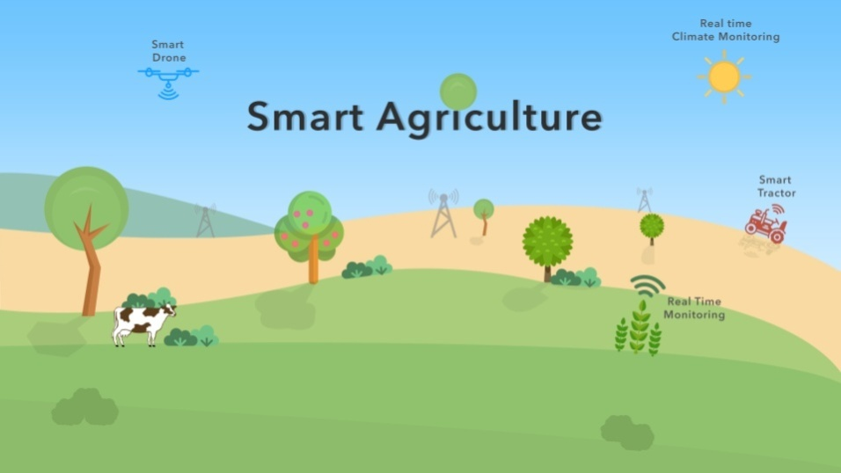 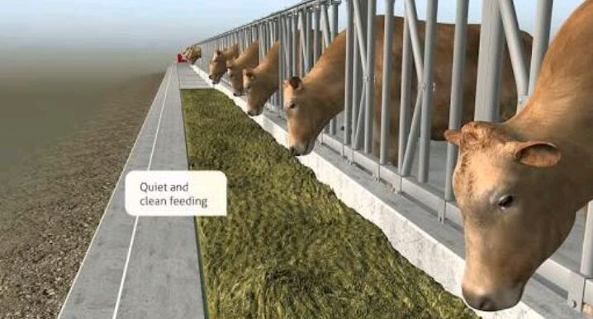

**8. CONCLUSION & FUTURE SCOPE**

**CONCLUSION:**

The primary applications for this project are for farmers and gardeners who do not have enough time to water their crops/plants and also useful for animal feeders to feed the livestock automatically. It also covers those farmers who are wasteful of water during irrigation. This proposed work is made to help the farmers and make their harvest economical by helping them in security purpose. By this work, the wastage of water and the consumption of power by motor can be reduced so that they are conserved for the future use. However, research indicates that different sensors types perform under all conditions with no negative impact on crop yields with reductions in water use range as high as 70% compared to traditional practices.

**FUTURE SCOPE**

A water meter can be installed to estimate the amount of water used for irrigation and thus giving cost estimation. A solenoid valve can be used for varying the volume of water flow. Furthermore, Wireless sensors can also be used. IoT sensors can be used to track an animal’s location, which can be helpful in locating sick animals as well as establishing and optimizing grazing patterns. Connected sensors in livestock wearables allow farmers to monitor heart rate, blood pressure, respiratory rate, temperature, digestion, and other vitals. Light sensor is used to detect light intensity of the environment. Light Dependent Resistor (LDR) is used in which the resistivity decreases with increase in light intensity and vice versa.LDR is used as sensor to turn on and off electric fence or provide artificial lighting for plantation of necessary. Camera is installed for the purpose of image detection when the movement is detected.

**10. REFERENCES**

* <http://cs.stanford.edu/projects>
* http://teks.co.in/site/blog/smart-irrigation-with-iot-top-12-things-to-know
* http://gardenbot.org/howTo/soilMoisture
* http://teks.co.in/site/blog/smart-irrigation-with-iot-top-12-things-to-know
* Nikesh Gondchawar, Dr. R.S.Kawitkar, “IoT Based Smart Agriculture”, International Journal on recent and innovation trends in Computing and Communication, Volume 5, Issue 2, PP 177-181, ISSN: 2321-8169, Feb 2016.
* http://web.science.mq.edu.au
* <http://www.electronics-tutorials.ws/combination/comb_6.html>
* http://cs.stanford.edu/projects

